**CHAPTER FOUR**

**SYSTEM DESIGN AND IMPLEMENTATION**

**OVERVIEW OF THE SYSTEM DESIGN**

System design is simply concerned with how to provide an efficient (economical) and effective (relevant and useful) system. It is an integral part of software development which is embarked on after a detail analysis of the system has been done and the project feasibility study undertaken. The purpose of the design is to meet the user’s specification of the system software, determine flexible system alternative that will achieve the recommended result and make optimum use of the hardware, software and other processing resources that may be used in the implementation.

**4.1 SYSTEM DESIGN**

The system is logically divided into two (2). They are:

1. The web store/ e-shop (Sahara fashion home customer’s interface)
2. The Database

**4.1.1 The web store/ e-shop**

The web store has a welcome page with Home, FAQ, Contact us, shopping cart. The marketer and the items needed to be purchased can be accessed from the home page. The catalogue contains information about the product to be sold and the price. It offers a link to the database where the transaction can be processed. Apart from these functions, the web stores also help to advertise the product of the marketers or sellers.

**4.2 THE DATABASE**

This involves specifying the nature and the structure of the database, the data being stored in the database and the data security measures enforced. It also specifies the data type and size. The system is scalable. It can be implemented at one level, and then expanded to keep up with growth or changes. Any change(s) can be stored in the system’s database.

The system has an updatable database. The database consists of tables that offer relational attributes with both primary and foreign keys. The database consists of tables that include:

1. Buyer registered table
2. Seller registered table
3. Shopping cart table
4. Sellers items table
5. E-transact pin code table
6. Product order table
   1. **INPUT/OUTPUT SPECIFICATION**

The database is created with MYSQL and it consists of several tables holding different data items:

**Buyer registration table**

|  |  |  |  |  |  |  |  |
| --- | --- | --- | --- | --- | --- | --- | --- |
| Name | Username | Password | Conf-password | sex | address | DOB | Security question |
|  |  |  |  |  |  |  |  |

Table 4.1: Buyer reg. records

**Seller registration table**

|  |  |  |  |  |  |  |
| --- | --- | --- | --- | --- | --- | --- |
| Marketer name | username | Password | Goods to sell | Contact address | sex | Shop No |
|  |  |  |  |  |  |  |

Table 4.2: Seller reg. records

**Shopping cart table**

|  |  |  |  |
| --- | --- | --- | --- |
| Items name | Price | Quality | Item No |
|  |  |  |  |

Table 4.3: Shopping cart

**Seller’s items table**

|  |  |  |  |  |  |  |
| --- | --- | --- | --- | --- | --- | --- |
| Customer_ID | Items | Quantity | Amount | First Name | Last Name | Zip code |
|  |  |  |  |  |  |  |

Table 4.4: seller’s items table

**E-transact pin code table**

|  |  |  |  |  |  |
| --- | --- | --- | --- | --- | --- |
| ID | Bank Name | Account Number | Amount | Password | Confirm Password |
|  |  |  |  |  |  |

Table 4.5: e-transact pin code table

**Product order table**

|  |  |  |  |  |  |  |
| --- | --- | --- | --- | --- | --- | --- |
| Customer_ID | Products | Quantity | Amount | First Name | Last Name | Zip code |
|  |  |  |  |  |  |  |

Table 4.6: product order table

**4.3 INPUT/ OUTPUT FORMAT**

Every program has input as well as output data. They are used mainly to achieve the specific objectives of verifying the processing operation being performed.

**4.3.1 Input format**

The input format is used essentially to state the data elements requested to serve as input to the system, computer is designed in such a way that sometimes it is called GIGO- denoting that what goes in is what comes out. The input forms are designs generally based on the necessary data that needs to be entered into the system. The data are captured through the keyboard and stored on a magnetic disk in MYSQL database.

**4.4 ACTIVITY DIAGRAM**

Activity diagrams are representative of step wise activities and actions in a system. They describe the operational step-by-step work flow (flowchart) of components in a system.

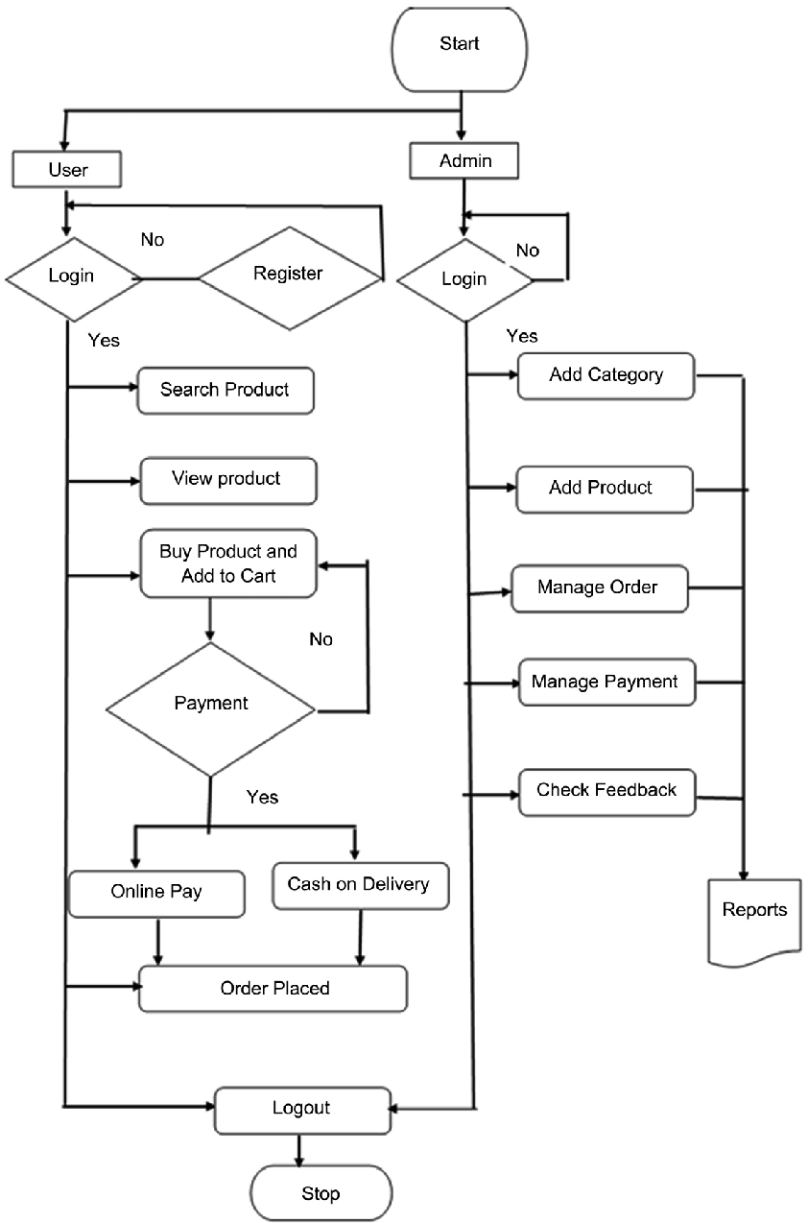

Figure 1: The Activity Diagram

* 1. **SYSTEM IMPLEMENTATION**

The implementation languages used in this project are PHP (Hypertext Preprocessor) and MYSQL (My Structure Query Language).

PHP is a general purpose server side scripting language originally designed for web development to produce dynamic web pages. PHP can be used with a large number of relational database management systems, runs on all of the most popular web servers and is available to many different operating systems.

MYSQL is a relational database management system written in C and C++, which runs as a server providing multi user access to a number of databases. MYSQL is used basically to create a relational database structure on a server in order to store data or automate procedures.

* 1. **SYSTEM TESTING STRATEGIES**

System testing is conducted on a complete integrated system to evaluate the system’s compliance with its specified requirements.

The system testing strategies used in this system include the unit test and integration test.

* + 1. **UNIT TEST**

The primary goal of unit testing is to take the smallest piece of testable software in the application, isolate it from the remainder of the code and determine whether it behaves exactly as it is expected to behave. Each unit is tested separately before integrating them into modules to test the interfaces between modules. Unit testing has proven its value in that a large percentage of defects are identified during its use.

During the unit testing of the application, errors uncovered by the researcher were rectified and the result was satisfactory.

**4.6.2 INTEGRATION TESTING**

Integration testing is a logical extension of unit testing. In its simplest form, the units that have already been tested are combined into a component and the interface between them is tested. A component, in this sense, refers to an integrated aggregate of more than one unit. In a realistic scenario, many units are combined into components, which are in turn aggregated into even larger parts of the program.

* 1. **TARGET COMPUTER SYSTEM REQUIREMENTS**

This section considers the requirements that must be met by the target system to enable the developed software application function as required. The target computer system requirement will be discussed in the area of software and hardware requirements.

|  |  |
| --- | --- |
| **Component** | **Requirement** |
| Operating system | Windows 2000, XP, Vista |
| Memory | 128MB or higher |
| Database | MySQL |
| Web server | XAMP server |

**Table 4.7: Software requirement for target computer system**

|  |  |
| --- | --- |
| **Component** | **Requirement** |
| RAM | 512MB of RAM and above |
| Hard disk | 10GB of hard disk space and above |
| Processor | 1GHz or higher |

**Table 4.8: Hardware requirements for target computer system**

Finally, the system requires a host. For people ware, the personnel that have been working with the old system can be trained in the use of the new system because of experience. A cooling system should also be provided for the computer systems, the dedicated server system running the software and workers in order to avoid damages and accident.

* 1. **SOFTWARE MAINTENANCE ISSUES**

This section focuses on software maintenance issues. Software maintenance is the modification of a software product after delivery to correct faults, improve performance or other product attributes or to adapt the product to a new or changing environment. It also serves as an opportunity to improve the performance of the software to suit the needs of the users if it becomes necessary for the user requirements to be improved upon or changed.

Maintenance could be seen in three areas in this project; corrective maintenance, preventive maintenance and adaptive maintenance.

* + 1. **CORRECTIVE MAINTENANCE**

Corrective maintenance is a maintenance task performed to identify, isolate and rectify a fault so that the failed system can be restored to an operational condition within the tolerances or limits established for in-service operations. Necessary corrections in the form of removal, modification or addition of program modules could be permitted by the software to allow for optimal use of the application.

* + 1. **PREVENTIVE MAINTENANCE**

This is a schedule of planned maintenance actions aimed at the prevention of breakdowns and failures. The primary goal of preventive maintenance is to prevent the failure of software before it actually occurs. It is designed to preserve and enhance software reliability by replacing error-prone components before they actually fail. Recent technological advances in tools for inspection and diagnosis have enabled more accurate and effective software maintenance.

**4.8.3 ADAPTIVE MAINTENANCE**

This involves enhancing the system by adding features, capabilities and functions in response to new technology, upgrades, new requirements or new problems. Since the environment in which the application would be running is dynamic, it should be made to suit whatever requirements that may change in the long run.